

SCHOOL OF ENGINEERING AND TECHNOLOGY
Main Campus, Off Hennur-Bagalur Main Road, Chagalahatti, Bengaluru, Karnataka- 562149
CAPSTONE PROJECT REPORT
ON
“AI-POWERED SMART HEALTHCARE MONITORING AND EMERGENCY RESPONSE SYSTEM USING EMBEDDED SYSTEM’’
Submitted to,
School of Engineering and Technology, CMR University
In partial fulfilment of the requirement for the award of the degree of

Bachelor Of Technology
in,
ELECTRONICS AND COMMUNICATION ENGINEERING
By
Chirag Sindhe [22BBTEC017]
K Niranjan [22BBTEC022]
K Venugopal Reddy [22BBTEC023]
Vijay Kumar G [22BBTEC064]
Under the Guidance of
Dr. Amrita Singh
Assistant Professor,
Department of Electronics and Communication Engineering,
School of Engineering and Technology
CMR University

DEPARTMENT OF ELECTRONICS AND COMMUNICATION ENGINEERING
CMR UNIVERSITY

2025-2026

SCHOOL OF ENGINEERING AND TECHNOLOGY
Main Campus, Off Hennur-Bagalur Main Road, Chagalahatti, Bengaluru, Karnataka- 562149
Department of Electronics and Communication Engineering
CERTIFICATE
This is to Certify that the Capstone Project work entitled “AI-Powered Smart Healthcare Monitoring and Emergency Response System using Embedded System” has been successfully carried out by Chirag Sindhe, K Niranjan, K Venugopal Reddy and Vijay Kumar G bearing USN 22BBTEC017, 22BBTEC022, 22BBTEC023, 22BBTEC064 in partial fulfilment for the award of the Degree BACHELOR OF TECHNOLOGY IN ELECTRONICS AND COMMUNICATION ENGINEERING by SCHOOL OF ENGINEERING AND TECHNOLOGY, CMR UNIVERSITY during the academic year 2025-2026. It is certified that all suggestions indicated for the Internal Assessment have been incorporated in the report deposited in the department library. The project report has been approved as it satisfies the academic requirements in respect of project work prescribed for the said Degree.

Signature of Guide Signature of HOD Signature of Dean
…………………… ..…………………… …………………..
Dr. Amrita Singh Dr. K.V. Prasad Dr. N. KANNAN

External Viva:
Name of the Examiners: Signature with Date:
1 …………………….
2…………………….

DECLARATION
We, Chirag Sindhe, K Niranjan, K Venugopal Reddy , Vijay Kumar G bearing university registration no. 22BBTEC017, 22BBTEC022, 22BBTEC023, 22BBTEC064 student of Bachelor of Technology, Electronics and Communication Engineering, School of Engineering and Technology, CMR University, Bengaluru, hereby declare that the Capstone project work entitled “AI-Powered Smart Healthcare Monitoring and Emergency Response System using Embedded System” submitted by us, for the award of the Bachelor’s degree in Electronics and Communication Engineering to CMR University is a record of Bonafide work carried out independently by us under the supervision and guidance of Dr. Amrita Singh Assistant Professor, ECE Dept. CMR University.
We further declare that the work reported in this project work has not been submitted and will not be submitted, either in part or in full, for the award of any other degree in this university or any other institute or University.

Place: Bengaluru
Date: 07/05/2026

Chirag Sindhe (22BBTEC017)
K Niranjan (22BBTEC022)
K Venugopal Reddy (22BBTEC023)
Vijay Kumar G (22BBTEC064)

PLAGIARISM CERTIFICATE

We hereby declare that the capstone project report entitled “AI-Powered Smart Healthcare Monitoring and Emergency Response System using Embedded System” submitted in partial fulfillment of the requirements for the award of the degree of BACHELOR OF TECHNOLOGY is a record of original work carried out by us.

We further declare that this report has not been submitted to any other university or institution for the award of any degree or diploma. All sources of information used in this project have been properly acknowledged through references and citations.

We also confirm that this report is free from plagiarism and AI score (maximum 25 % is allowed) and complies with the academic integrity guidelines prescribed by the institution.

Place: Bengaluru
Date: 07/05/2026

Chirag Sindhe (22BBTEC017)
K Niranjan (22BBTEC022)
K Venugopal Reddy (22BBTEC023)
Vijay Kumar G (22BBTEC064)

ACKNOWLEDGEMENTS
The satisfaction that comes with the successful completion of this project would be incomplete without acknowledging the individuals who made this work possible. Their constant guidance, encouragement, and support played a vital role throughout the project.
We consider ourself privileged to express our sincere gratitude to all those who guided us during the completion of this project. We express our thanks to our Project Guide, Dr. Amrita Singh, Assistant Professor, Department of Electronics and Communication Engineering, School of Engineering and Technology, CMR University, for her constant support.
We would like to extend our thanks to Dr. Brijesh Mishra, Capstone Project Coordinator and Dr. K.V. Prasad, Head of the Department, Department of Electronics and Communication Engineering, School of Engineering and Technology, CMR University, Bengaluru, for his encouragement and motivation throughout the project work.
We also express our heartfelt gratitude to Dr. N. KANNAN, Dean, School of Engineering and Technology, CMR University, for his support.

(Chirag Sindhe)
(K Niranjan)
(K Venugopal Reddy)
(Vijay Kumar G)

ABSTRACT
With the rapid growth of embedded systems and IoT technologies, healthcare monitoring has become more accessible and efficient. This project focuses on developing an AI-powered smart healthcare monitoring and emergency response system that can continuously track important health parameters in real time while remaining simple, portable, and cost-effective.
The system is designed to monitor key physiological signals such as heart rate, blood oxygen saturation (SpO₂), and body temperature using wearable sensors. These sensors are connected to an ESP32 microcontroller, which collects and processes the data continuously. Instead of using complex algorithms, a straightforward threshold-based approach is applied to identify whether the patient’s condition is normal or abnormal, allowing faster decision-making with minimal processing load.
To make the system more practical, real-time data is sent to a web-based dashboard using MQTT protocol, where users can easily view the patient’s health status through a clear and color-coded interface. In addition to this, a GSM module is included to send instant SMS alerts during emergency situations. This feature ensures that alerts can still be delivered even when internet connectivity is unavailable, which is especially useful in remote areas.
The overall design focuses on reliability, low power consumption, and ease of use, making it suitable for home healthcare, elderly monitoring, and continuous patient observation. Testing results show that the system provides consistent readings and responds quickly to abnormal conditions.
In summary, this project presents a practical and efficient healthcare monitoring solution that combines embedded systems with communication technologies to improve patient safety and enable timely medical response, while also leaving scope for future enhancements.

Table of Contents
Chapter No | Title | Page No.
 | Abstract | VI
1 | Introduction | 4
1 | 1.1 Background | 4
1 | 1.2 Problem Statement | 4
1 | 1.3 Research Gaps | 5
1 | 1.4 Objective | 5
1 | 1.5 Novelty of the work | 5
1 | 1.6 Challenges | 6
1 | 1.7 Report Organisation | 6
2 | Literature Survey | 8
2 | 2.1 Survey | 8
2 | 2.2 Existing Works | 8
2 | 2.3 Research Gap | 9
2 | 2.4 Proposed Work Motivation | 9
2 | 2.5 Literature Survey Table | 10
3 | Methodology | 12
3 | 3.1 Method | 12
3 | 3.2 Implementation Procedure | 12
3 | 3.3 Flow chart | 14
3 | 3.4 Block diagram | 15
3 | 3.5 Data Collection and Analysis methods | 15
3 | 3.6 Unique Features | 16
3 | 3.7 Advantages | 16
4 | Software and Hardware requirements | 17
4 | 4.1 Requirements | 17
4 | 4.2 Brief Description about the tools to be used | 19
5 | Result and discussion | 20
5 | 5.1 Experimental Results/ Simulation Outcomes | 20
5 | 5.2 Discussion and Interpretation of Results | 23
 | Applications | 24
 | Future scope | 24
 | Challenges | 25
 | Conclusion | 26
 | References | 27

List of Figure
Figure | Page No.
Fig 3.1 Flow chart of Health Monitoring System | 14
Fig 3.2 Block diagram of the System | 15
Fig 5.1 Web-Based Patient Monitoring Dashboard | 20
Fig 5.2 Heart Rate Monitoring Graph | 21
Fig 5.3 SpO₂ Monitoring Graph | 21
Fig 5.4 Body Temperature Monitoring Graph | 22
Fig 5.5 SMS Alert Output for Emergency Condition | 22
Fig: 5.6 Serial monitor output showing sensor readings and system status. | 23

List of Tables
Tables | Page No.
Table 2.1: Literature Survey Table | 10
Table 4.1: Hardware Components used in the developed system | 17
Table 4.2: Software Tools Used in the designed system | 18

Chapter 1

INTRODUCTION
  - Background
In recent years, healthcare systems have started using digital technologies to improve patient monitoring and overall care [1][12]. Traditionally, patient health was monitored using hospital-based equipment, which is accurate but often expensive, bulky, and limited to clinical environments. These systems do not allow continuous monitoring and restrict patient movement, making them less appropriate for long-term use, especially for elderly people and patients with chronic diseases [19]. With the development of embedded systems and IoT technology, more compact and body-worn healthcare systems have been introduced [2][17]. These systems can continuously measure key physiological signals such as heart rate, SpO₂, and body temperature using integrated sensors [3][5]. The collected information can be processed in real time, helping in timely identification of abnormal conditions. In addition, wearable systems allow patients to be monitored outside hospitals, improving accessibility and convenience [18].
However, many existing solutions depend heavily on internet connectivity and remote cloud platforms for data transmission and analysis [11][13]. This can lead to delays and reduced reliability, particularly in emergency situations or in regions with limited network coverage. Because of this, there is a requirement for a simple, low-cost, and reliable healthcare monitoring system capable of functioning with minimal internet dependency while still providing quick emergency alerts.
  - Problem Statement
Many current healthcare monitoring solutions are expensive, less portable, and mostly designed for use within hospital environments. Although recent IoT-based solutions allow remote monitoring, they depend heavily on continuous internet connectivity for transmitting data and generating alerts [2][11][33]. This creates a major limitation, as the system may fail or become unreliable in regions with limited network coverage or during emergency situations. In addition, several existing solutions are complex and consume more power, which makes them less suitable for wearable and long-term usage [6][21]. Because of these limitations, there is a requirement to develop a simple, low-cost, and portable health monitoring system capable of functioning in real time [32]. The system should be capable of providing immediate emergency alerts using alternative communication methods, without depending entirely on internet connectivity.

  - Research Gaps
From the study of existing healthcare monitoring systems, several limitations can be observed. Many systems depend mainly on cloud-based processing and constant internet access, which can cause delays during emergency situations [11][13][33]. Also, most of these solutions do not provide a reliable offline alert mechanism that can work independently when network access is not available. Another issue is that existing solutions are often complex and consume more energy, making them less suitable for long-term wearable use [6][21]. Furthermore, such systems are not easily accessible in rural or low-resource areas where proper healthcare infrastructure is limited. Some systems also lack simple and user-friendly interfaces, making them challenging for non-technical users to operate. These gaps emphasize the requirement for a simple, efficient, and cost-effective health monitoring solution capable of providing real-time monitoring and reliable emergency alerts without depending completely on internet connectivity.
  - Objective
The primary objective of this project is to design a smart healthcare monitoring system that can continuously track important physiological parameters in real-time conditions. The developed system measures heart rate, SpO₂, and body temperature using wearable sensors, and the collected data is processed using an ESP32 microcontroller. By using a threshold-based method, the system can quickly detect abnormal health conditions. Another objective is to implement a dependable emergency notification mechanism through a GSM module, which allows messages to be sent directly to caregivers without relying on internet connectivity. The system also uses MQTT for transmitting data to a web dashboard, where the patient’s health status can be monitored remotely in real time.
  - Novelty of the work
The uniqueness of the proposed system is reflected in its ability to provide reliable healthcare monitoring without complete dependence on internet connectivity. In contrast to several existing solutions that rely mainly on cloud-based communication [11][13], this system combines MQTT-based data transmission with GSM-based alert mechanisms. This dual communication approach ensures that real-time monitoring and emergency alerts can function even in situations where internet access is limited or unavailable. Another key feature of this system is the implementation of a simplified threshold-based analysis method, which reduces system complexity while still providing effective detection of abnormal health conditions. The system is developed to remain compact and wearable, allowing continuous monitoring without affecting user mobility. In addition, the use of a color-coded web dashboard improves the ease of understanding for users, making the system suitable even for non-technical individuals.
The focus on low-cost components and energy-efficient design further makes the system practical for real-world applications, especially in rural and resource-limited environments.
  - Challenges
During the system development phase, several challenges were faced. A key challenge was ensuring accurate and stable sensor readings, as physiological data is often affected by noise [5][20]. To handle this, simple filtering techniques were used. Power consumption was another concern since the system has been developed to be portable [21]. The GSM module also introduced challenges like signal strength and network availability, which can affect alert delivery. The ESP32 has limited processing capability, so lightweight algorithms were used to ensure real-time performance. Integrating sensors, GSM, and MQTT communication into a single system also required careful testing. Ensuring quick detection of abnormal conditions and fast alert generation was an important part in the overall system design.
  - Report Organisation
Chapter 1: Introduction
This chapter emphasizes the rising importance of continuous and dependable health monitoring solutions in the modern healthcare domain. Traditional monitoring approaches are largely limited to hospital environments, which increases cost and makes them less suitable for remote or long-term usage. With recent developments in embedded technologies and connected smart systems, continuous observation of key physiological parameters such as heart rate, blood pressure, oxygen saturation (SpO₂), and body temperature has become more practical and accessible. The main objective of this project is to create a compact, affordable, and portable health monitoring system that can detect abnormal conditions and deliver immediate alerts without complete dependence on constant internet connectivity.
Chapter 2: Literature Survey
This chapter offers a review of various IEEE research works related to smart healthcare monitoring systems, wearable sensors, and wireless communication technologies. Many existing systems utilize IoT platforms, Wireless Body Area Networks (WBANs), and cloud-based solutions to enable continuous patient monitoring and remote access to health data. Nevertheless, these systems frequently depend on stable internet connectivity, which can lead to delays and reduced reliability during emergency situations. Furthermore, challenges such as greater system complexity, elevated power consumption, and concerns related to data security and privacy are observed. With respect to the proposed AI-powered smart healthcare monitoring system, a research gap is identified in designing a simple, cost-effective, and reliable system that can operate with limited internet dependency.

Chapter 3: Block Diagram
This chapter describes the overall architecture of the proposed AI-powered intelligent healthcare monitoring system illustrated through a block diagram. The system integrates wearable sensors, an ESP32 microcontroller, a GSM communication module, and an MQTT-based data transmission mechanism. The ESP32 acts as the main processing unit, continuously acquiring sensor readings and analysing it instantly using predefined threshold values. The processed information is transferred using MQTT protocol for efficient and low-latency communication to a web-based dashboard, where health parameters are displayed in a user-friendly color-coded format. In emergency conditions, whenever abnormal values are identified, the GSM module (SIM800L) sends alert messages to predefined contacts, ensuring immediate response even in the absence of internet connectivity.
Chapter 4: Methodology
This chapter explains the step-by-step working process of the proposed healthcare monitoring system. At the beginning, the wearable devices continuously gather important physiological parameters such as heart rate, SpO₂, and body temperature. The processed data is then handled by the ESP32 microcontroller, which evaluates the values against predefined threshold limits to determine the patient’s condition. Based on this comparison, the system identifies whether the condition is normal, warning, or critical. If any abnormal condition is detected, the GSM module is used to immediately send an alert message to the registered contacts.
Along with this, the system also enables real-time monitoring by sending the data through MQTT to a web dashboard, where the health status is displayed clearly. The overall method is simple and efficient, reducing complexity while ensuring reliable performance, which makes it suitable for embedded healthcare applications.
Chapter 5: Results and Discussion
This chapter explains the results obtained after testing the developed healthcare monitoring system. During the testing phase, we observed that the system was able to continuously measure heart rate, SpO₂, and body temperature with stable readings. The data was transmitted using MQTT and displayed on the web dashboard, making it easy to understand the patient’s condition in real time. The GSM module was also tested for emergency situations, and it successfully sent alert messages immediately when abnormal values were detected. The response was quick, which is important for timely medical attention. Overall, the system showed reliable performance under different conditions. The use of GSM communication further improved the system’s dependability, especially in situations where internet connectivity is not available.
Chapter 2

LITERATURE SURVEY
2.1 Survey
In recent times, there has been a growing interest in wearable healthcare monitoring systems due to the advancement of IoT technologies [1][12]. Many research works focus on continuously monitoring vital parameters such as heart rate, SpO₂, and body temperature using sensors connected to microcontrollers [3][5]. Several IoT-based systems transmit data to cloud platforms, allowing doctors to monitor patients remotely in real time [2][11][33]. However, these solutions rely significantly on stable internet connectivity, which may act as a constraint in emergency situations or rural areas [14].
Wearable sensor-based solutions have been extensively studied, as they provide compact, low-power solutions for continuous monitoring while improving patient mobility [6][20]. Furthermore, Wireless Body Area Networks (WBANs) enable multiple sensors to communicate efficiently, although they often increase system complexity and power consumption [7][8][25][35]. Some advanced systems use cloud computing and data analytics for long-term monitoring, but this adds complexity and raises privacy concerns [10][13][22]. On the other hand, GSM-based approaches provide a more reliable alternative for emergency alerts without relying on the internet.
In summary, current studies indicate that while real-time monitoring is possible, there is still a need for a simple, low-cost, and efficient system capable of operating effectively with minimal internet dependency.
2.2 Existing Works
Existing healthcare monitoring systems can be broadly classified into IoT-based, cloud-based, and wearable sensor-based approaches [1][12]. IoT-based systems mainly use microcontrollers such as Arduino or ESP32 to collect physiological data and transmit it for monitoring. Such systems are commonly utilized because they are flexible and relatively easy to implement. However, most of them depend on constant internet access for data transmission and alert generation, which can reduce reliability in certain situations [11][14].
Cloud-based healthcare systems offer additional features such as data storage, analysis, and remote access for doctors and caregivers [11][30][33]. Although these features are beneficial for long-term monitoring, they also introduce latency and depend heavily on network availability. This can affect system performance, especially during emergency conditions where quick response is required.
Wearable healthcare devices have gained popularity due to their compact size and ability to provide continuous monitoring [17][18][23]. These systems use small sensors to track vital parameters and improve patient mobility. However, many existing wearable devices are either expensive or do not include dependable emergency alert mechanisms. Some research efforts have focused on improving efficiency by optimizing embedded system design and reducing power consumption [6][21]. Even with these improvements, issues such as system complexity, higher cost, and reliance on network infrastructure still exist. Overall, even though current systems can effectively monitor patient health, they often fail to achieve a proper balance between cost, simplicity, reliability, and reduced dependency on internet connectivity.
2.3 Research Gap
From the evaluation of existing healthcare monitoring systems, several important research gaps can be identified. Many systems rely heavily on constant internet access, which reduces their reliability in regions with limited network coverage or during emergency situations [11][13][33]. In addition, there is an absence of efficient offline alert mechanisms that can function independently without internet support.
Another limitation is the high system complexity and cost, which makes these solutions less accessible, especially in rural or low-resource environments [21]. Furthermore, advanced system designs often lead to higher energy consumption, making them unsuitable for long-term wearable use [6][7][29]. Many existing systems also do not focus enough on user-friendly interfaces, making them challenging for non-technical users to operate.
These limitations emphasize the requirement for a simple, cost-effective, and reliable healthcare monitoring system capable of functioning in real time while reducing dependency on continuous internet connectivity.
2.4 Proposed Work Motivation
To overcome the limitations identified in existing systems, the proposed work focuses on developing a low-cost wearable healthcare monitoring device that can continuously track vital parameters and provide reliable emergency communication [24][28]. Unlike many current solutions, the system includes a GSM-based alert mechanism, which allows emergency messages to be sent even without internet connectivity. This improves the reliability of the system, especially in rural and remote areas.
The system also uses MQTT for efficient data transmission to a web dashboard, enabling real-time monitoring with low latency [30]. A simple threshold-based analysis method is used to detect abnormal conditions, which helps in reducing computational complexity while maintaining effective performance. In addition, the web interface is designed with a clear and user-friendly display, making it easy for users to understand the health status. Overall, the proposed system provides a practical solution that balances cost, efficiency, and reliability, making it suitable for real-world healthcare applications.

2.5 Literature Survey Table
6
Table 2.1: Literature Survey Table
Author | Overview | Findings of the Study
Islam et al. (2015) | Presented a comprehensive survey on IoT in healthcare, focusing on remote patient monitoring, smart medical devices, and healthcare communication systems [1]. | Concluded that IoT improves healthcare efficiency, enables real-time monitoring, and supports better patient care services.
Philip et al. (2021) | Proposed IoT-based in-home health monitoring systems for continuous patient observation and remote diagnosis [2]. | Demonstrated that IoT systems enhance home healthcare quality and reduce hospital dependency.
Wu et al. (2020) | Developed a wearable health monitoring system capable of measuring physiological parameters in real time [3]. | Showed that wearable devices improve patient mobility and support continuous health tracking.
Chen et al. (2016) | Introduced smart clothing integrated with IoT and cloud computing for healthcare monitoring applications [4]. | Proved that smart wearable textiles enable seamless health data collection and cloud-based analysis.
Patel et al. (2012) | Reviewed wearable sensors and monitoring systems used in biomedical and healthcare applications [5]. | Identified wearable sensors as effective tools for continuous physiological monitoring and medical assistance.
Pantelopoulos & Bourbakis (2010) | Surveyed wearable biosensor systems for health monitoring and patient assistance [6]. | Demonstrated that biosensor systems improve patient safety and support real-time medical monitoring.
Cao et al. (2009) | Discussed enabling technologies for Wireless Body Area Networks (WBANs) in healthcare systems [7]. | Highlighted that WBANs provide reliable communication for wearable healthcare devices.
Otto et al. (2006) | Proposed a wireless body area sensor network architecture for medical monitoring applications [8]. | Showed that sensor networks improve real-time data transmission and healthcare accessibility.
Zhang et al. (2017) | Developed Health-CPS, a healthcare cyber-physical system integrating sensors, communication, and computing technologies [9]. | Proved that cyber-physical healthcare systems enhance patient monitoring and emergency response.
Kumar & Lee (2012) | Investigated security challenges in healthcare sensor networks and IoT-based medical systems [10]. | Concluded that secure communication protocols are essential for protecting patient health data.
Botta et al. (2016) | Studied the integration of cloud computing and IoT for smart healthcare applications [11]. | Demonstrated that cloud-enabled IoT systems improve scalability, storage, and healthcare analytics.
Al-Fuqaha et al. (2015) | Reviewed IoT enabling technologies, communication protocols, and applications in healthcare and smart systems [12]. | Highlighted the importance of IoT in developing intelligent and interconnected healthcare environments.
Gia et al. (2015) | Proposed fog computing architecture for healthcare IoT applications to reduce latency and improve data processing [13]. | Showed that fog computing enhances real-time healthcare monitoring efficiency.
Hassan et al. (2017) | Developed fog computing-based smart healthcare systems for efficient patient data processing and communication [14]. | Demonstrated reduced response time and improved healthcare service reliability.
Mansour et al. (2021) | Designed an AI-enabled IoT healthcare model for disease prediction and patient monitoring [15]. | Proved that AI integration improves diagnosis accuracy and healthcare decision-making.
Khan et al. (2022) | Reviewed AI and IoT integration in smart healthcare systems for predictive analysis and automation [16]. | Concluded that AI-based IoT systems enhance healthcare intelligence and reduce manual intervention.
Li et al. (2017) | Investigated digital health and wearable monitoring technologies for healthcare applications [17]. | Demonstrated that wearable monitoring systems improve preventive healthcare and patient management.
Jovanov (2019) | Explored the role of IoT-enabled wearable devices in smart healthcare applications [18]. | Showed that wearables support remote monitoring and improve healthcare accessibility.
Varshney (2014) | Discussed pervasive healthcare systems and wireless monitoring technologies for continuous patient observation [19]. | Highlighted that wireless monitoring enhances healthcare availability and emergency response.
Baig et al. (2013) | Conducted a comprehensive survey on wearable sensors for healthcare monitoring systems [20]. | Concluded that wearable sensors provide efficient, portable, and real-time health monitoring solutions.

Chapter 3
METHODOLOGY
3.1 Method
The methodology used for the proposed healthcare monitoring system is based on continuous data collection, real-time processing, and reliable communication. The system works as an integrated unit where physiological parameters are measured using wearable sensors and processed locally using an embedded microcontroller. The ESP32 acts as the main controller, managing the flow of data between the sensors, processing unit, and communication modules. The collected data is analysed in real time using simple processing techniques to detect any abnormal conditions. Based on this, the system transmits data through MQTT for monitoring and uses GSM communication for emergency alerts when required. The overall approach focuses on maintaining accuracy while keeping the system simple and efficient, ensuring fast response and suitability for real-time healthcare applications.
3.2 Implementation Procedure
1. System Initialization
The system starts by initializing all hardware components, including the ESP32 microcontroller, MAX30102 pulse oximeter sensor, DS18B20 temperature sensor, GSM module (SIM800L), and power supply unit. Communication protocols such as GPIO pins are configured to ensure proper interaction between all components.
2. Sensor Data Acquisition
The MAX30102 sensor continuously measures heart rate and blood oxygen saturation (SpO₂) using optical sensing, while the DS18B20 sensor records body temperature. These sensors send real-time data to the ESP32 at regular intervals.
3. Data Preprocessing and Filtering
The raw sensor data may contain noise due to motion or environmental factors. To improve accuracy, the ESP32 applies simple filtering techniques such as averaging and removal of outliers, ensuring stable and reliable data.
4. Real-Time Data Processing
The ESP32 processes the filtered data continuously and evaluates new readings as soon as they are received, enabling real-time operation.
5. Threshold-Based Analysis
Each parameter is compared with predefined threshold values representing normal, warning, and critical conditions. Based on this comparison, the system determines the health status.
6. Health Condition Classification
The system classifies the condition into normal, warning, or critical. If all values are within range, monitoring continues. If any value exceeds limits, it is treated as an abnormal condition.
7. Emergency Alert Activation
When a critical condition is detected, the ESP32 triggers the GSM module (SIM800L), which sends an SMS alert to predefined contacts with details of the abnormal condition.
8. Data Transmission to Web Interface
The ESP32 transmits the processed data to a web-based application using MQTT protocol over Wi-Fi, enabling real-time remote monitoring.
9. Visualization and User Interface
The web interface displays the data using a simple color-coded format (normal, warning, critical), making it easy for users to understand the health status.
10. Continuous Monitoring Loop
The entire process runs continuously in a loop, where data is repeatedly collected, processed, analysed, and transmitted, ensuring uninterrupted monitoring and quick response to changes.

3.3 Flow chart
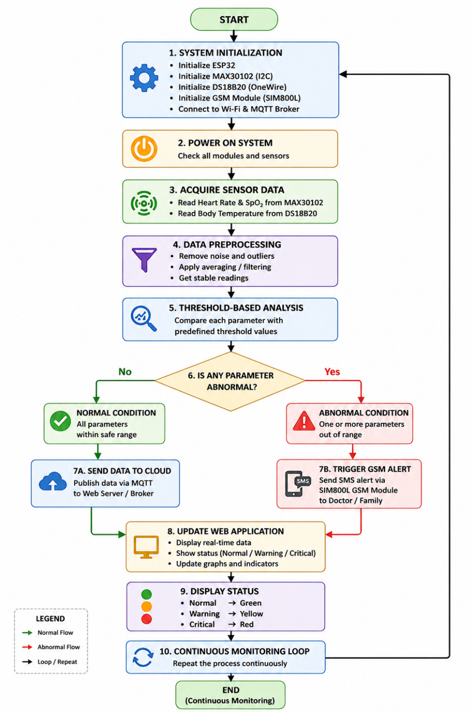
Fig 3.1: Flow Chart of Health Monitoring System
The flowchart shows the working of the healthcare monitoring system. The system starts by initializing all components and then continuously collects sensor data such as heart rate, SpO₂, and body temperature. The data is processed and compared with predefined threshold values.
If the values are normal, the data is sent to the web application using MQTT for real-time monitoring. If any abnormal condition is detected, the GSM module sends an alert message to the user. The process repeats continuously to ensure real-time monitoring [2][30].

3.4 Block diagram
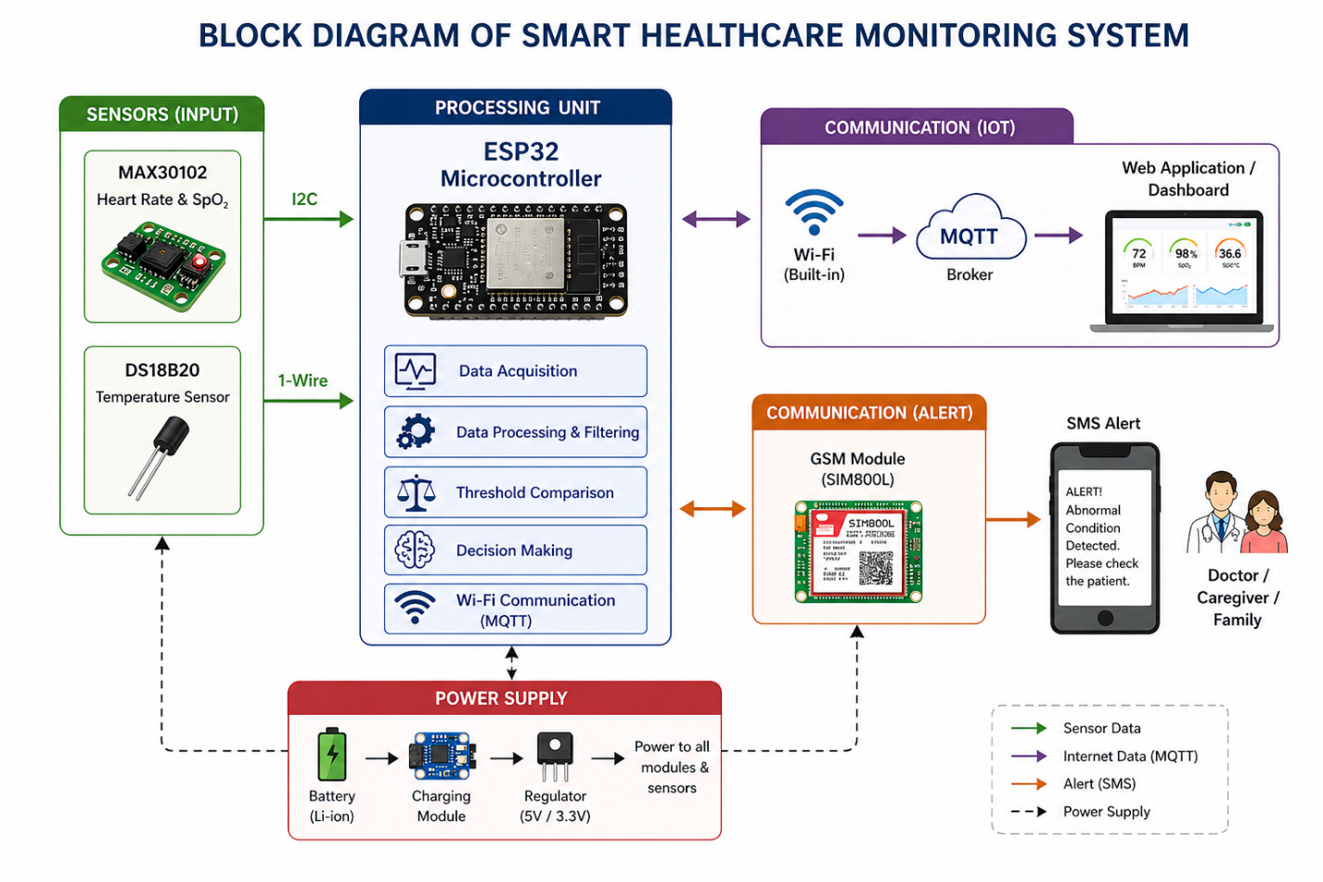
Fig 3.2: Block Diagram of Health Monitoring system
The block diagram shows the working of the healthcare monitoring system. Sensors collect heart rate, SpO₂, and temperature data and send it to the ESP32. The ESP32 processes the data and sends it to a web application using MQTT for monitoring [28]. If any abnormal condition is detected, the GSM module sends an alert message. The system runs continuously using a battery power supply.
3.5 Data Collection and Analysis Methods
Data collection in the proposed system is performed continuously using sensors placed on the user’s body [5][24]. These sensors measure vital parameters in real time and send the data to the ESP32 microcontroller for processing. To improve reliability, simple filtering techniques are used to reduce noise and fluctuations in the readings [20]. The collected data is analysed using a threshold-based approach, where each parameter is compared with predefined safe limits. Based on this comparison, the system classifies the condition as normal, warning, or critical. This method is lightweight and suitable for embedded systems, allowing quick decision-making while maintaining accuracy in detecting abnormal conditions [6].

3.6 Unique Features
The proposed system includes several features that improve its performance in real-world applications. One important feature is the use of GSM communication for emergency alerts, which allows the system to work even without internet connectivity. This makes it suitable for use in rural and remote areas.
The system also supports real-time monitoring using MQTT, allowing data to be viewed on a web dashboard [2][30]. The compact and wearable design makes it easy to use for continuous monitoring [5][24]. In addition, the use of a simple threshold-based method reduces system complexity while still providing reliable performance [6].
3.7 Advantages
The developed healthcare monitoring system offers several advantages that improve its practicality in real-world applications. One of the main benefits is its cost-effectiveness, as it uses low-cost components and a simple design, making it suitable for users in rural and resource-limited environments [21].
The system supports continuous tracking of vital parameters including heart rate, SpO₂, and body temperature measurements, allowing timely detection of irregular conditions [3][5]. The use of threshold-based analysis reduces computational complexity, allowing fast and efficient processing on embedded hardware like ESP32 [6]. The integration of GSM communication improves system reliability by enabling emergency alerts even without internet connectivity. At the same time, MQTT-based communication allows real-time data transmission to an online dashboard for remote monitoring [2][30]. This combination ensures both uninterrupted monitoring and rapid emergency response.
The system is compact and portable, making it suitable for wearable applications [17][18]. Its low power consumption supports longer operation using a battery [21]. In addition, the web interface uses a simple color-coded display, making it easy for users to interpret the health condition without technical knowledge. Overall, the system provides a good balance of affordability, reliability, efficiency, and user-friendliness, making it suitable for modern healthcare monitoring applications.

Chapter 4
SOFTWARE & HARDWARE REQUIREMENT SPECIFICATION
4.1 Requirements
4.1.1 Hardware Requirements
The hardware setup of the developed system consists of multiple components that handle sensing, processing, communication, and power supply. The main component is the ESP32 microcontroller, which functions as the main control unit. It collects data from sensors, processes it in real time, and controls communication modules. The ESP32 is selected because of its low power consumption, built-in Wi-Fi support, and good performance for embedded applications [21]. The MAX30102 sensor is used to measure heart rate and blood oxygen saturation (SpO₂) using optical sensing [3][5]. The DS18B20 sensor is utilized for monitoring body temperature and provides accurate digital output, making it suitable for continuous monitoring.
For emergency communication, the SIM800L GSM module is used to send SMS alerts to predefined contacts without relying on internet connectivity. This improves system reliability, especially in remote areas. The system is powered by a rechargeable Li-Po battery, which supports portability [21]. A TP4056 charging module is used for safe charging and battery protection. Additional components such as connecting wires, PCB or breadboard, and optional indicators like LEDs or buzzers are used for proper system integration. Overall, the selected hardware ensures an optimal balance of performance, cost, and energy efficiency, making the system suitable for wearable healthcare applications [17][18].
Table 4.1: Hardware Components used in the developed system
Sl. No. | Hardware Component | Model / Specification | Purpose / Function
1 | Microcontroller | ESP32 | Acts as the main processing unit of the system. It collects sensor data, performs threshold-based analysis, controls communication modules, and interfaces with the web application using MQTT communication.
2 | Pulse Oximeter Sensor | MAX30102 | Measures heart rate and blood oxygen saturation (SpO₂) levels continuously using optical sensing techniques.
3 | Temperature Sensor | DS18B20 | Measures the patient’s body temperature with high accuracy and digital output.
4 | GSM Module | SIM800L | Sends emergency SMS alerts to caregivers or medical personnel when abnormal health conditions are detected.
5 | Power Supply | Rechargeable Li-Po Battery | Provides portable power supply to the system for continuous operation.
6 | Charging Module | TP4056 | Manages safe charging and protection of the Li-Po battery.

4.1.2 Software Requirements
The software requirements of the developed system consist of programming, data processing, and visualization tools that support the overall operation of the hardware. The system is developed using the Arduino IDE, which provides a simple environment for writing and uploading code to the ESP32 microcontroller. The programming is done using Embedded C, allowing efficient control of sensors, communication modules, and data processing. Libraries are implemented to interface with the MAX30102 and DS18B20 sensors, making data acquisition easier and more accurate [3][5]. The software performs real-time processing and uses threshold-based analysis to detect abnormal health conditions quickly [6].
For remote monitoring, a web-based application is developed using HTML, CSS, and JavaScript. The ESP32 sends data to this interface using MQTT communication, where the readings are displayed instantaneously [2][30]. A color-coded format is applied to indicate normal, warning, and critical conditions for better understanding. During development and testing, serial monitoring tools are used to observe system behaviour and verify sensor readings. Overall, the software ensures smooth communication between components, accurate data processing, and easy user interaction.
Table 4.2: Software Tools Used in the designed system
Tool | Purpose
Arduino IDE | Programming ESP32
Embedded C | Code development
MQTT Protocol | Data transmission
HTML/CSS/JS | Web dashboard

4.2 Brief Description about the tools to be used
The developed healthcare monitoring system integrates a combination of hardware components and software tools to achieve accurate sensing, real-time processing, and reliable communication. Each component is selected based on its functionality, efficiency, and compatibility with embedded applications. The ESP32 microcontroller acts as the central processing unit of the system. It is an energy-efficient device with built-in Wi-Fi support, making it suitable for IoT applications. It acquires data from sensors, processes it using threshold-based logic, controls the GSM module, and transmits data to the web interface. The MAX30102 sensor is used to measure heart rate and blood oxygen saturation (SpO₂) using optical sensing. The DS18B20 is a precise digital temperature sensor that delivers accurate readings with a simple one-wire interface, reducing wiring complexity.
The SIM800L GSM module is used for sending SMS alerts during emergency conditions. It allows the system to function without internet connectivity, improving reliability in critical situations. The system is powered by a rechargeable Li-Po battery, and a TP4056 module is used for safe charging and protection. This setup ensures portability and continuous operation. For software development, the Arduino IDE is used to program the ESP32 using Embedded C. It provides a simple interface and supports various libraries for sensor and communication integration. A web-based application is developed using HTML, CSS, and JavaScript to display real-time health data. The ESP32 sends data using MQTT, and the interface presents it in a color-coded format to indicate normal, warning, and critical conditions, making it easy for users to understand.

Chapter 5

RESULTS AND DISCUSSION

5.1 Experimental Results / Simulation Outcomes
5.1.1 Web-Based Patient Monitoring Dashboard
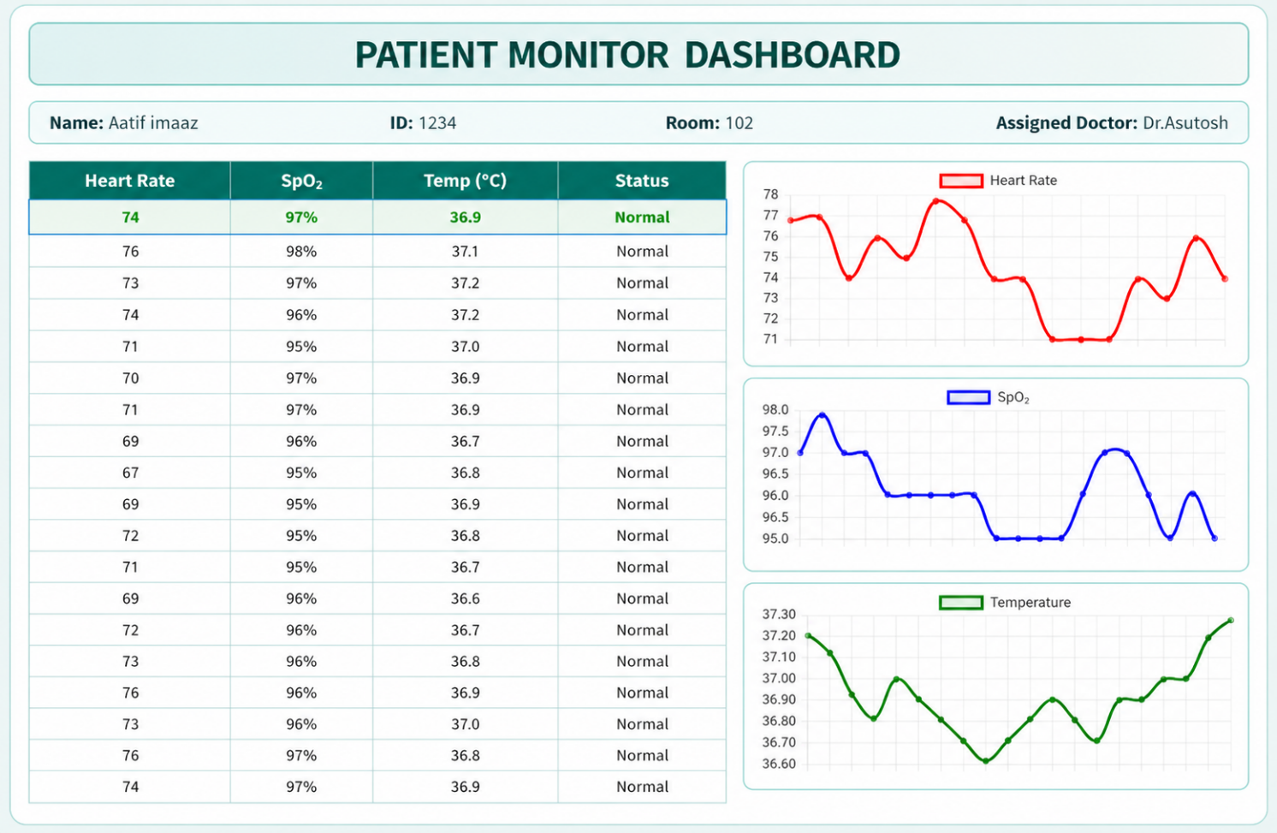
Fig 5.1: Web-Based Patient Monitoring Dashboard
The figure shows the patient monitoring dashboard used for real-time visualization of health data. It displays important parameters such as heart rate, SpO₂, and body temperature in both tabular and graphical formats. The system updates the data continuously using MQTT communication, allowing remote monitoring of the patient’s condition. The graphs provide a clear view of parameter variations over time, while the table shows current readings along with the health status. A color-coded system is used to indicate normal, warning, and critical conditions, making it easy for users to understand the patient’s health quickly. This enhances usability and helps in quick decision-making during emergency situations. Additionally, the dashboard provides a centralized platform for monitoring multiple parameters simultaneously, improving overall system efficiency. It also allows caregivers to track trends and identify any sudden changes in the patient’s condition effectively.
5.1.2 Heart Rate Monitoring Graph
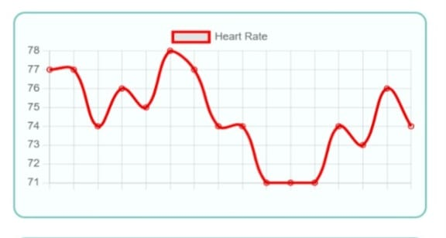
Fig 5.2: Heart Rate Monitoring Graph
The graph shows heart rate changes over time. The values vary slightly but remain within a normal range, indicating stable heart activity. This stability confirms that the system is capable of accurately monitoring heart rate without significant fluctuations or errors.
5.1.3 SpO₂ Monitoring Graph
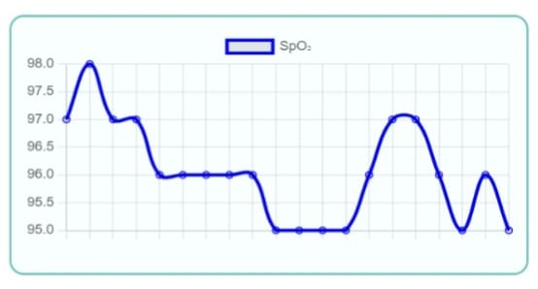
Fig 5.3: SpO₂ Monitoring Graph
The graph shows SpO₂ levels over time. The values slightly fluctuate but remain within a normal range, indicating stable oxygen levels. This consistency demonstrates that the system can reliably monitor oxygen saturation without significant deviations.
5.1.4 Body Temperature Monitoring Graph
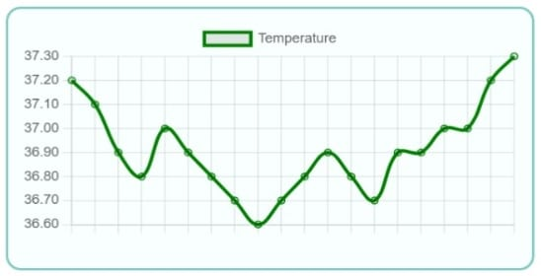
Fig 5.4: Body Temperature Monitoring Graph
The graph shows temperature variation over time. The values slightly fluctuate within the normal range, indicating stable body temperature. This indicates that the system is able to monitor temperature accurately without significant variations.
5.1.5 SMS Alert Output for Emergency Condition
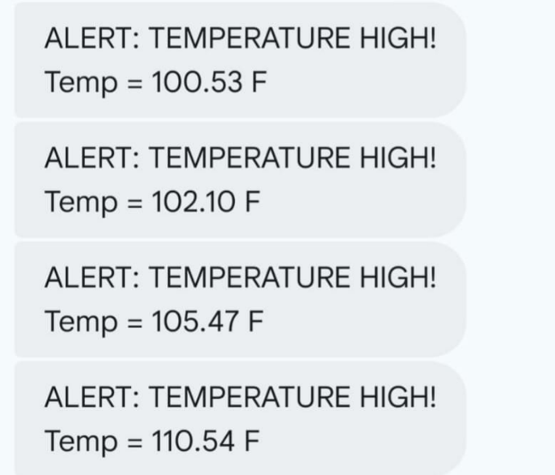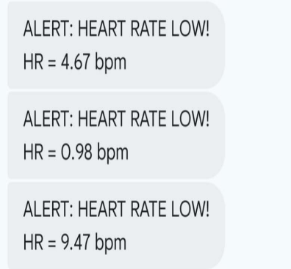
Fig 5.5: SMS Alert Output for Emergency Condition
The images show SMS alert messages sent to a mobile phone using the SIM800L GSM module when abnormal conditions are detected. These alerts notify caregivers about high temperature and low heart rate for quick response. This ensures timely communication and enables immediate action to prevent critical health situations.
5.1.6 Serial monitor output showing sensor readings and system status.
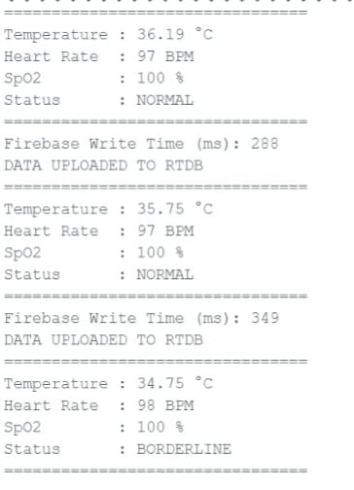
Fig 5.6: Serial monitor output showing sensor readings and system status.
The image shows serial monitor output displaying real-time sensor data such as temperature, heart rate, and SpO₂ along with system status. It also confirms successful data transmission to the database.
5.2 Discussion and Interpretation of Results
The outcomes achieved from the proposed healthcare monitoring system show that it can perform continuous and reliable real-time monitoring of vital parameters. The sensor readings for heart rate, SpO₂, and body temperature showed consistent values under standard conditions, indicating proper functioning of the sensing and processing units. The use of simple filtering techniques helped reduce noise and improved the accuracy of the readings. The web-based dashboard displays the collected data in both tabular and graphical formats, making it easy to observe changes over time. The color-coded status system (normal, warning, critical) helps users quickly understand the patient’s condition.
The graphs show variations in heart rate, SpO₂, and temperature, proving that the system can capture real-time changes accurately. The system responds quickly to abnormal conditions by detecting values beyond predefined limits and activating the alert mechanism. The GSM module successfully sends SMS alerts within a short time, ensuring timely communication with caregivers. This improves system reliability, especially in areas with poor or no internet connectivity.
Overall, the system provides a good balance of accuracy, efficiency, and reliability, confirming that the proposed design is effective for practical healthcare monitoring applications.

Chapter 6

APPLICATIONS, FUTURE SCOPE AND CHALLENGES
Applications:
The developed healthcare monitoring system offers several practical applications due to its portability, affordability, and real-time monitoring capability. One major application is in home healthcare, where patients can be monitored continuously without frequent hospital visits. This is especially useful for patients with chronic conditions or those recovering from illness, as it helps in early detection of abnormal conditions. The system is also suitable for older individuals, where continuous health tracking is important for safety. As aged individuals are more susceptible to sudden health changes, the system’s real-time monitoring and alert features help ensure quick medical response.
It is highly useful in rural and remote areas where access to healthcare facilities and internet connectivity is limited. The use of GSM communication allows reliable alert transmission even without internet, improving healthcare accessibility. Furthermore, the system can be utilized in small healthcare units as a support tool for monitoring patients. It can also be applied in fitness and wellness tracking, where individuals can track their physiological parameters and remain informed about their health status.
Future scope:
The developed system operates efficiently, but there is scope for further improvement. One possible enhancement is the use of advanced computational intelligence techniques for predictive analysis. Instead of only using threshold-based detection, intelligent models can process historical data to predict potential health issues at an early stage. The system can also be improved by integrating cloud storage, which would allow long-term data analysis and remote access for healthcare professionals. This can help in better patient management and record keeping.
Another enhancement is the development of a mobile application for real-time notifications and easier access to health data. This would improve user interaction and make the system more convenient to use. Additional sensors such as ECG, blood pressure, and respiratory rate sensors can be added to provide more detailed health monitoring. Improving sensor accuracy and calibration can further increase system reliability. Security can be enhanced by implementing data encryption and secure communication methods to protect sensitive health data. Also, optimizing power consumption and using better battery technologies can improve portability and increase system operating time.

Challenges:
Although the developed system offers multiple benefits, it also encounters certain limitations that must be addressed for large-scale use. One major issue is the accuracy of sensor data, as wearable sensors can be affected by movement, environmental conditions, and improper placement. Proper calibration and basic signal processing are required to maintain reliable readings.
Power consumption is another challenge, since continuous monitoring and communication can drain the battery quickly. Efficient power management is necessary to support longer operation in wearable applications.
The system also depends on GSM network availability for sending alerts. In areas with weak signals, the reliability of message delivery may be affected. This limitation can be improved by integrating additional communication methods.
Data privacy and security are also important concerns, as healthcare data is sensitive. Secure transmission and storage methods are required to protect user information.
Finally, the system currently uses a threshold-based approach, which may not effectively identify complex health conditions. This can be improved in the future by incorporating more advanced analysis techniques.

Chapter 7

CONCLUSIONS
The proposed work successfully demonstrates the design and implementation of a smart healthcare monitoring and emergency response system using embedded systems and IoT technologies. The system is capable of continuously monitoring vital parameters such as heart rate, SpO₂, and body temperature in real time. By integrating wearable sensors with the ESP32 microcontroller, the system efficiently collects and processes data with low computational complexity.
The use of a threshold-based analysis method enables quick and reliable detection of abnormal health conditions. A key feature of the system is the GSM-based alert mechanism, which ensures that emergency notifications are sent to caregivers even without internet connectivity. This improves system reliability, especially in rural and low-network areas.
The web-based dashboard allows real-time visualization of data using graphs and color-coded indicators, making it easy to understand the patient’s condition. The results show that the system provides stable readings, accurate detection, and timely alerts.
In addition, the system is low-cost, portable, and energy-efficient, making it suitable for home healthcare, elderly monitoring, and remote applications. Although some limitations exist, the system provides a strong base for future improvements.
Overall, the project demonstrates an effective and practical approach to healthcare monitoring by combining embedded systems, IoT, and communication technologies to improve patient safety and enable timely medical response.

REFERENCES
[1] S. M. R. Islam, D. Kwak, M. H. Kabir, M. Hossain, and K.-S. Kwak, “The Internet of Things for health care: A comprehensive survey,” IEEE Access, vol. 3, pp. 678–708, 2015.
[2] N. Y. Philip, J. J. P. C. Rodrigues, H. Wang, S. J. Fong, and J. Chen, “Internet of Things for in-home health monitoring systems,” IEEE J. Sel. Areas Commun., vol. 39, no. 2, pp. 300–310, 2021.
[3] T. Wu, F. Wu, J. M. Redoute, and M. R. Yuce, “A wearable health monitoring system,” IEEE Internet Things J., vol. 7, no. 8, pp. 6932–6945, 2020.
[4] M. Chen, Y. Ma, J. Song, C. Lai, and B. Hu, “Smart clothing: Connecting human with clouds and big data,” IEEE Internet Things J., vol. 3, no. 5, pp. 825–845, 2016.
[5] S. Patel, H. Park, P. Bonato, L. Chan, and M. Rodgers, “A review of wearable sensors and systems,” IEEE J. Biomed. Health Inform., vol. 16, no. 3, pp. 414–427, 2012.
[6] A. Pantelopoulos and N. Bourbakis, “A survey on wearable biosensor systems,” IEEE Trans. Syst., Man, Cybern., vol. 40, no. 1, pp. 1–12, 2010.
[7] H. Cao, V. Leung, C. Chow, and H. Chan, “Enabling technologies for wireless body area networks,” IEEE Commun. Mag., vol. 47, no. 12, pp. 84–93, 2009.
[8] C. Otto, A. Milenkovic, C. Sanders, and E. Jovanov, “System architecture of a wireless body area sensor network,” IEEE J. Biomed. Health Inform., 2006.
[9] Y. Zhang, M. Qiu, C.-W. Tsai, M. Hassan, and A. Alamri, “Health-CPS: Healthcare cyber-physical system,” IEEE Syst. J., vol. 11, no. 1, pp. 88–95, 2017.
[10] P. Kumar and H.-J. Lee, “Security issues in healthcare sensor networks,” IEEE Sensors J., vol. 12, no. 1, pp. 55–91, 2012.
[11] A. Botta, W. De Donato, V. Persico, and A. Pescapé, “Integration of cloud computing and IoT,” IEEE Commun. Surveys Tuts., vol. 18, no. 1, pp. 44–71, 2016.
[12] A. Al-Fuqaha, M. Guizani, M. Mohammadi, M. Aledhari, and M. Ayyash, “Internet of Things: Enabling technologies and applications,” IEEE Commun. Surveys Tuts., vol. 17, no. 4, pp. 2347–2376, 2015.
[13] T. N. Gia, M. Jiang, A. M. Rahmani, T. Westerlund, and P. Liljeberg, “Fog computing in healthcare IoT,” in Proc. IEEE CIT, 2015.
[14] M. M. Hassan, K. Lin, X. Yue, and J. Wan, “Fog computing in smart healthcare,” IEEE Wireless Commun., vol. 24, no. 4, pp. 96–102, 2017.
[15] R. F. Mansour et al., “AI-enabled IoT healthcare model,” IEEE Access, vol. 9, pp. 45137–45146, 2021.
[16] J. Khan, F. Khan, and S. Ahmad, “AI and IoT in smart healthcare systems,” IEEE Access, vol. 10, pp. 62613–62660, 2022.
[17] X. Li et al., “Digital health and wearable monitoring,” IEEE Rev. Biomed. Eng., vol. 10, pp. 85–97, 2017.
[18] E. Jovanov, “Wearables meet IoT: Applications in smart healthcare,” IEEE Internet Things J., vol. 6, no. 2, 2019.
[19] U. Varshney, “Pervasive healthcare and wireless health monitoring,” IEEE Comput., vol. 40, no. 12, 2014.
[20] M. M. Baig, H. GholamHosseini, and M. Connolly, “A comprehensive survey of wearable sensors,” IEEE Rev. Biomed. Eng., vol. 6, 2013.
[21] A. K. Sangaiah, M. Sadeghilalimi, A. A. R. Hosseinabadi, and W. Zhang, “Energy consumption in point-of-care IoT systems: A review,” IEEE Internet Things J., vol. 6, no. 6, pp. 10231–10248, 2019.
[22] S. R. Moosavi et al., “End-to-end security scheme for mobility enabled healthcare IoT,” IEEE Internet Things J., vol. 5, no. 5, pp. 3269–3280, 2018.
[23] H. Ghayvat, S. Mukhopadhyay, X. Gui, and N. Suryadevara, “WSN- and IoT-based smart homes and their extension to smart buildings,” Sensors, vol. 15, no. 5, pp. 10350–10379, 2015.
[24] D. Ndzi, M. Ismail, A. I. Abdalla, and K. A. Al-Saffar, “Wireless sensor network for healthcare monitoring: A survey,” IEEE Access, vol. 8, pp. 222403–222417, 2020.
[25] M. Chen, S. Gonzalez, A. Vasilakos, H. Cao, and V. C. Leung, “Body area networks: A survey,” Mobile Netw. Appl., vol. 16, no. 2, pp. 171–193, 2011.
[26] P. Gope and T. Hwang, “BSN-care: A secure IoT-based modern healthcare system using body sensor network,” IEEE Sensors J., vol. 16, no. 5, pp. 1368–1376, 2016.
[27] A. Meharouech, J. Elias, and A. Mehaoua, “Future body area networks: A survey,” IEEE Commun. Surveys Tuts., vol. 21, no. 4, pp. 3367–3403, 2019.
[28] S. Ullah et al., “A comprehensive survey of wireless body area networks,” J. Med. Syst., vol. 36, no. 3, pp. 1065–1094, 2012.
[29] M. Patel and J. Wang, “Applications, challenges, and prospective in emerging body area networking technologies,” IEEE Wireless Commun., vol. 17, no. 1, pp. 80–88, 2010.
[30] A. Rahmani et al., “Exploiting smart e-health gateways at the edge of healthcare IoT,” Future Gener. Comput. Syst., vol. 78, pp. 641–658, 2018.
[31] S. Yin et al., “A deep learning approach for IoT-based healthcare systems,” IEEE Access, vol. 6, pp. 32956–32964, 2018.
[32] J. Qi, P. Yang, G. Min, O. Amft, F. Dong, and L. Xu, “Advanced internet of things for personalized healthcare systems: A survey,” IEEE Internet Things J., vol. 4, no. 5, pp. 1498–1515, 2017.
[33] M. Hassanalieragh et al., “Health monitoring and management using Internet-of-Things (IoT) sensing with cloud-based processing,” in Proc. IEEE Int. Conf. Services Comput., 2015.
[34] F. Touati and R. Tabish, “U-healthcare system: State-of-the-art review and challenges,” J. Med. Syst., vol. 37, no. 3, 2013.
[35] K. S. Kwak, S. Ullah, and N. Ullah, “An overview of IEEE 802.15.6 standard,” in Proc. IEEE Int. Symp. Applied Sciences Biomed. Commun. Technol., 2010.

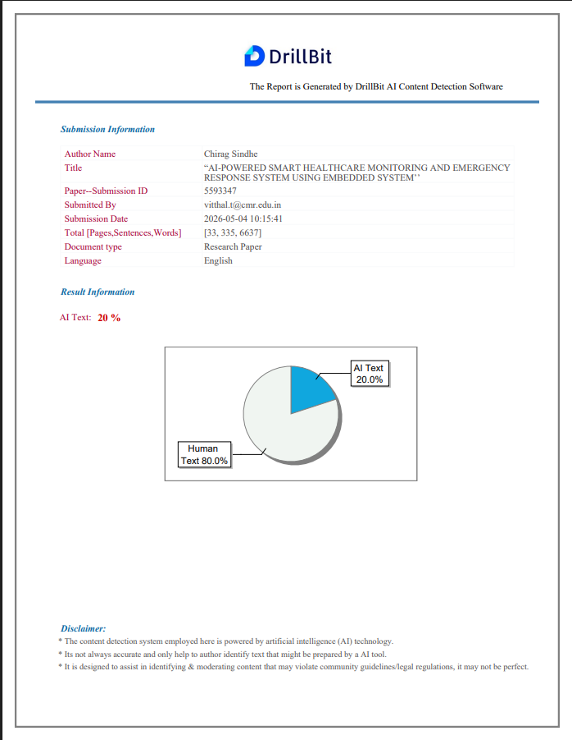
PLAGIARISM & AI REPORT


